**IST-652**

**Mini Project 2**

**Twitter Data Exploration**

(Using Semi-structured data)

**By:**

**Ankita Vartak**

**ajvartak@syr.edu**

|  |
| --- |
| Table Content |
| 1. Introduction |
| 1. Dataset |
| 1. Part 1: Extract and summarize twitter hashtags |
| 1. Part 2: Sentimental Analysis |
| 1. Part 3: Processing a JSON File with Twitter Data |
| 1. Part 4: Extracting tweets by Username for analysis |

1. **Introduction**

In this project, I have used semi-structured data from Twitter API and analyzed it with the help of the Tweepy library. I have used some standard natural language processing (also known as text mining) approaches to do this. I have also done word bigrams and twitter word frequency analysis. At last, I have done sentimental analysis using the textblob library in python.

The project is divided into 3 parts:

1. Part 1: **Extract and summarize twitter hashtags**
2. Part 2: **Sentimental Analysis**
3. Part 3: **Processing a JSON File with Twitter Data**
4. **Dataset**

In this project, the dataset is in JSON format. I have used the tweepy Cursor interface to extract and iterate tweets in python.

1. **Part 1: Extract and summarize twitter hashtags**

Here, I have used ‘#climate+change -filter: retweets’ as my search query to fetch 100 tweets from Twitter. I initialized the data frame using the pandas library to populate each tweet. I used 8 attributes from the Twitter object namely - user_name, user_location, user_description, user_verified, date, text, hashtags, and source.

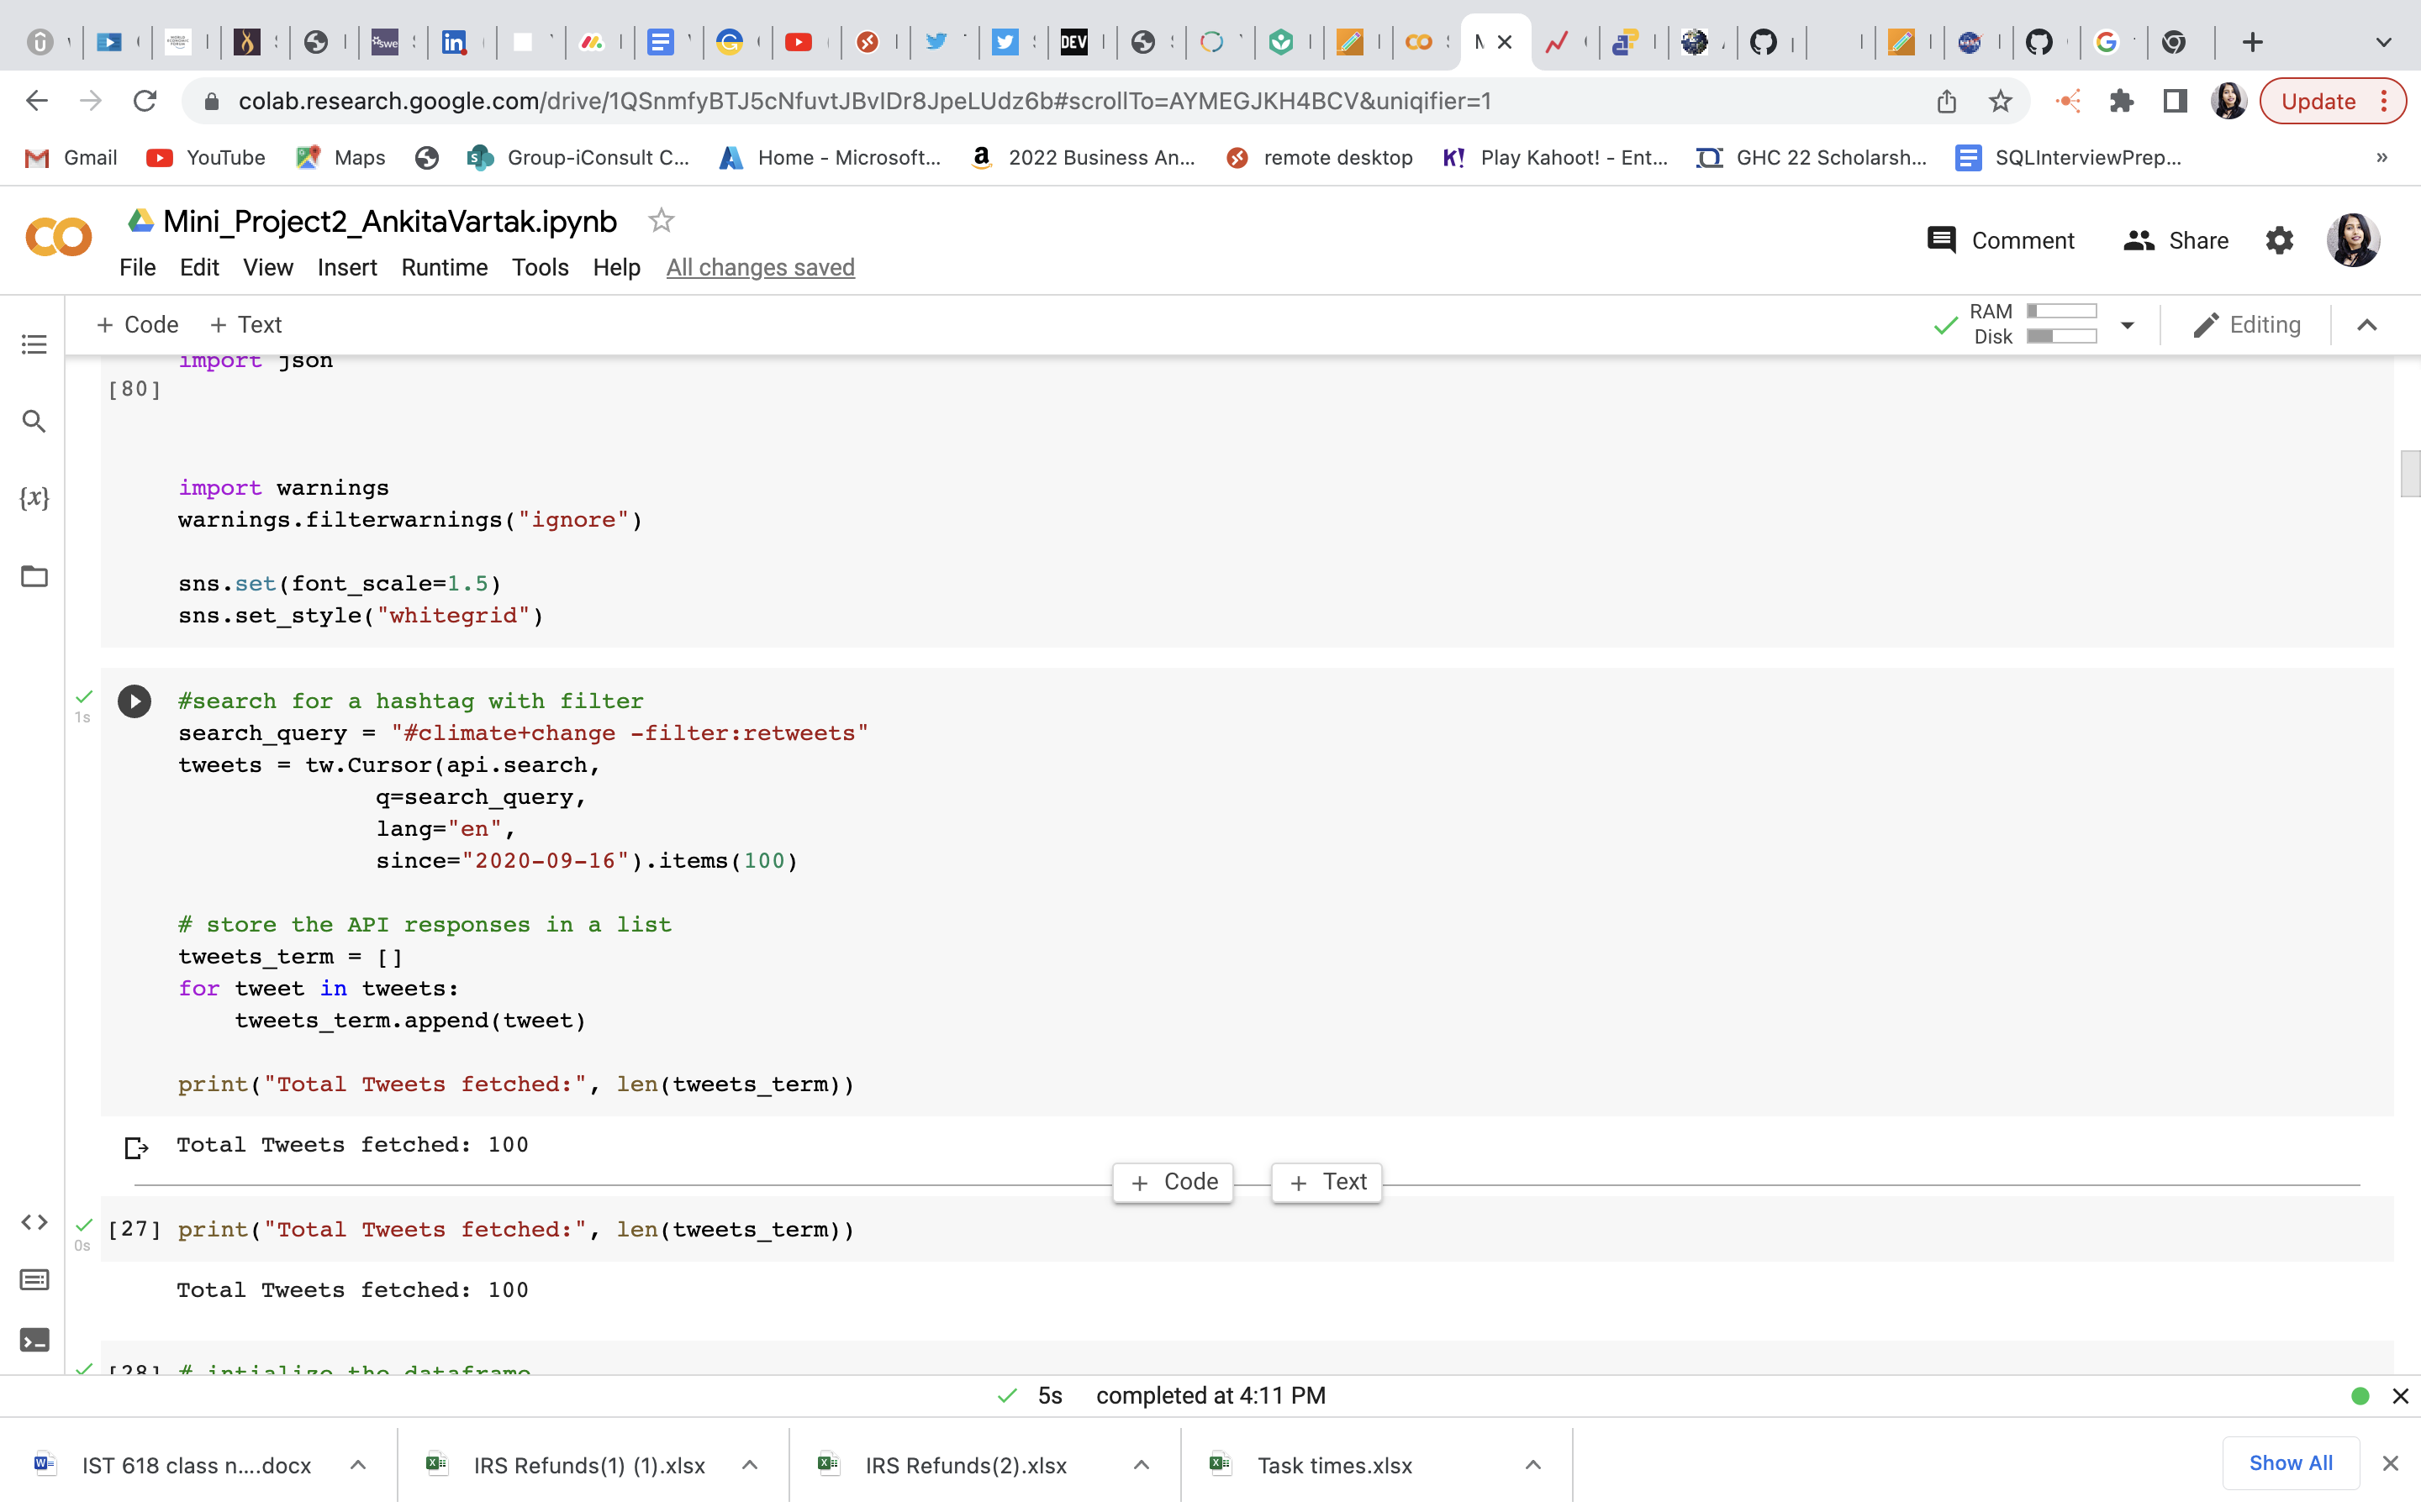

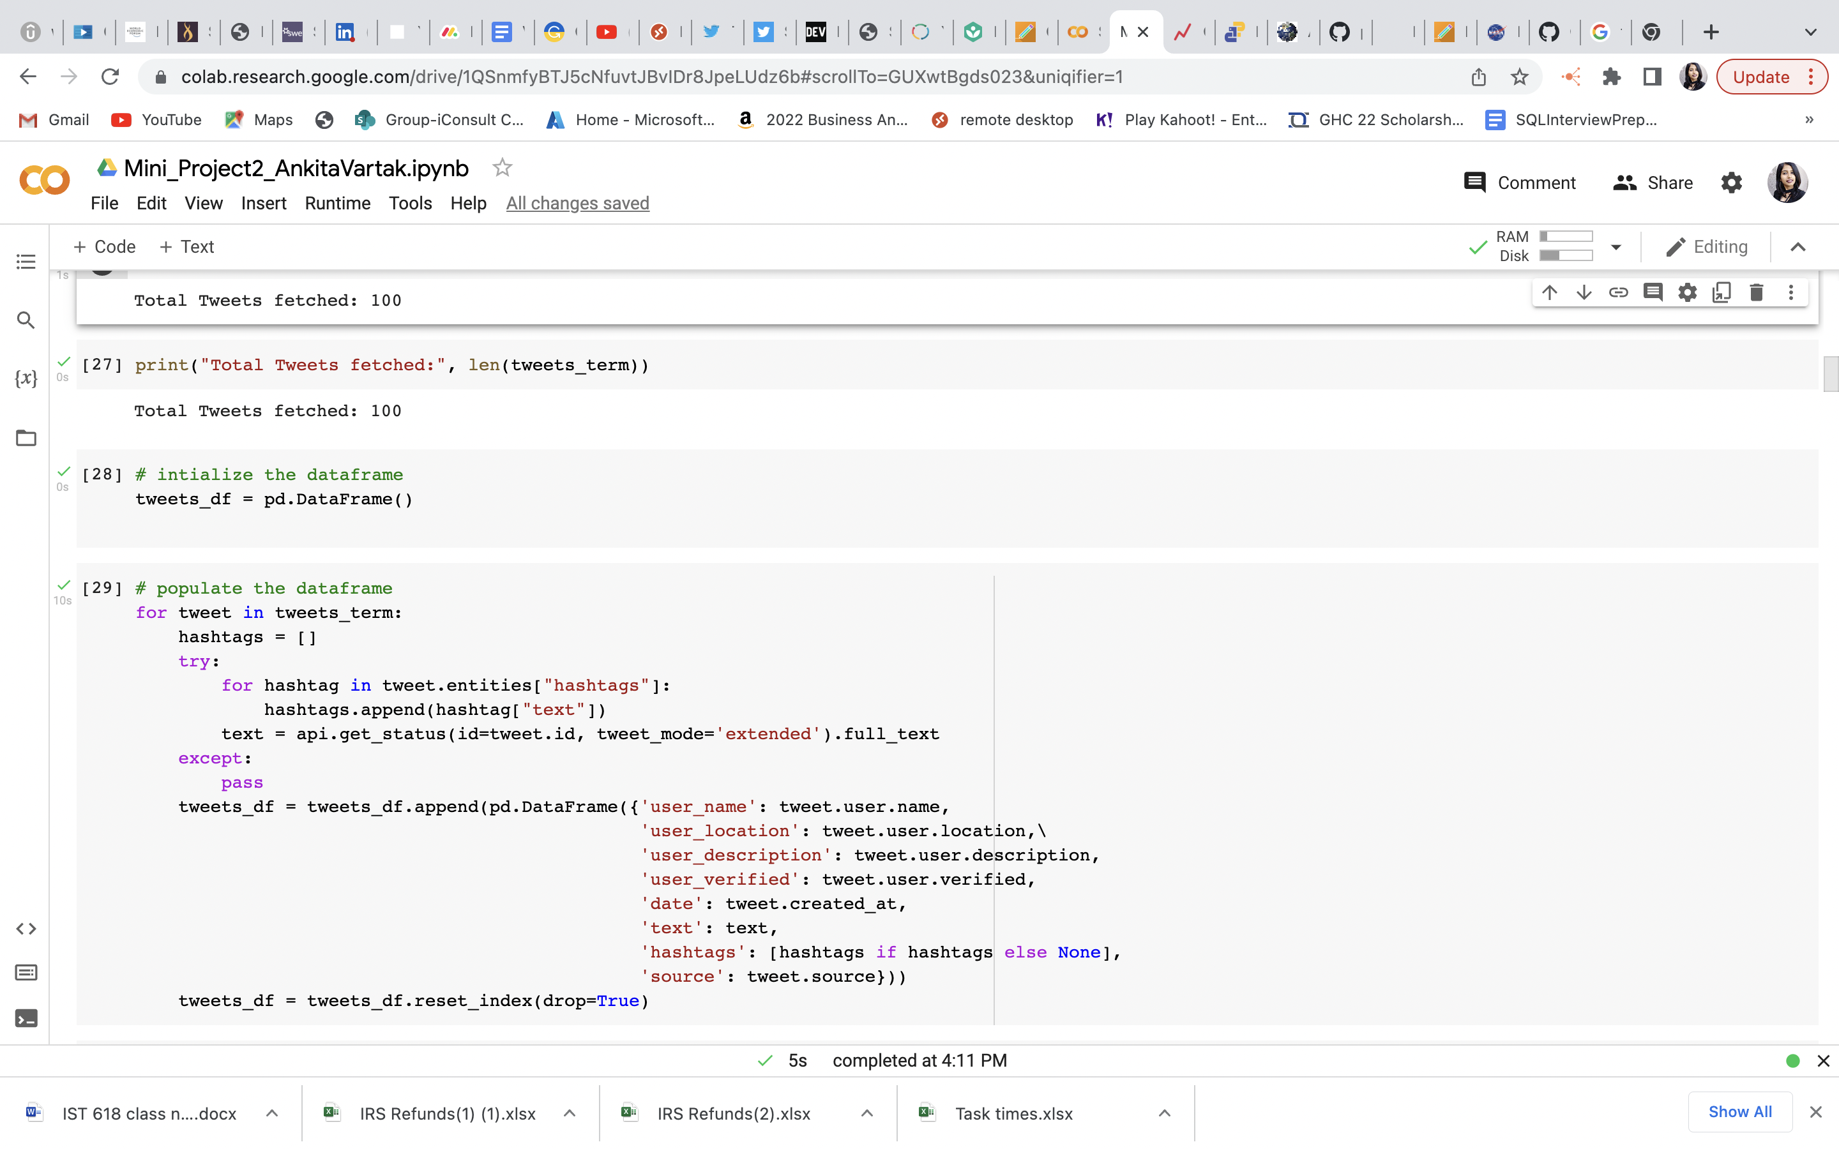

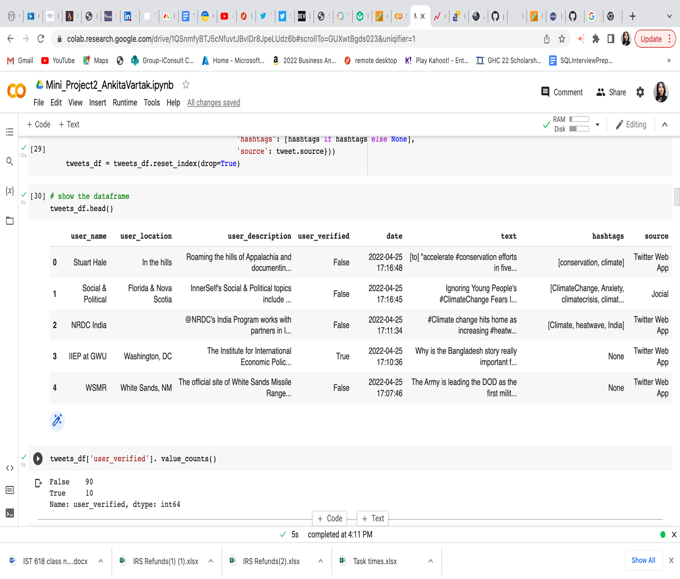

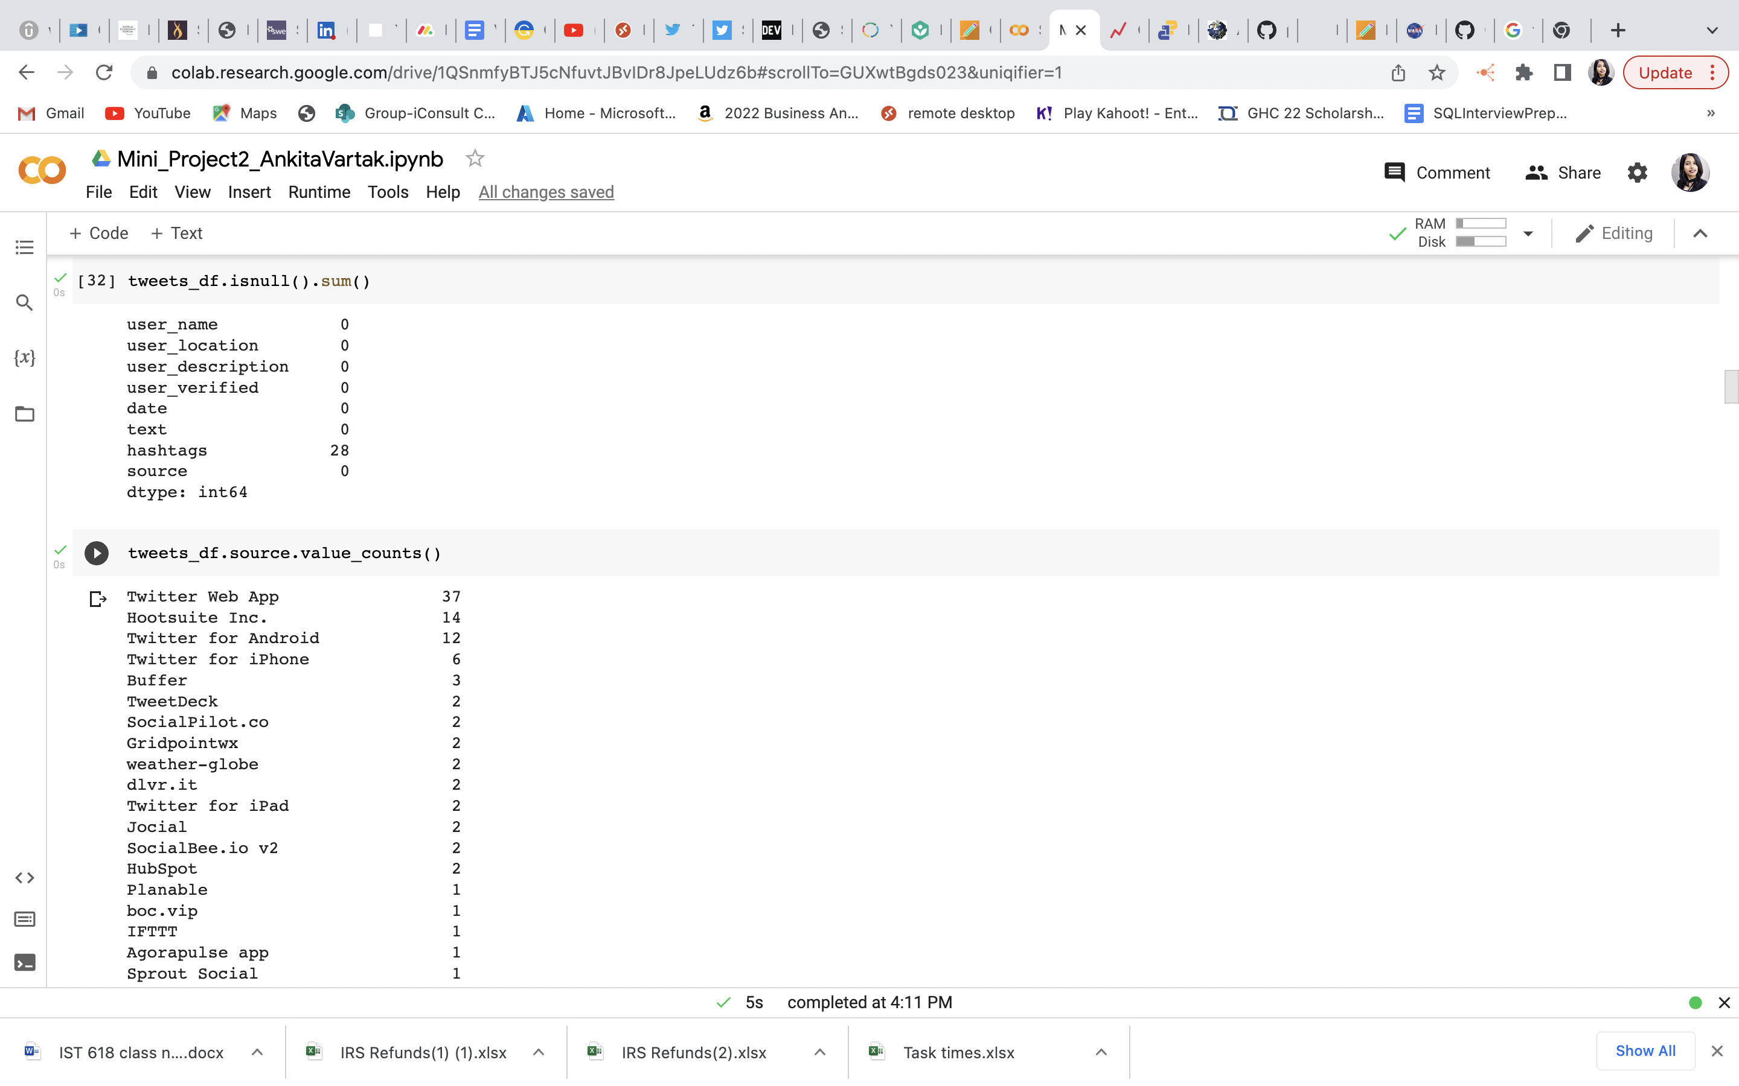

tweets_df.isnull( ).sum( )

* is used for checking which twitter object has null values: Therefore, we can see that hashtags have 28 null values.

tweets_df.user_location.value_counts()

* is used to get the pivot table for a summary of verified accounts.

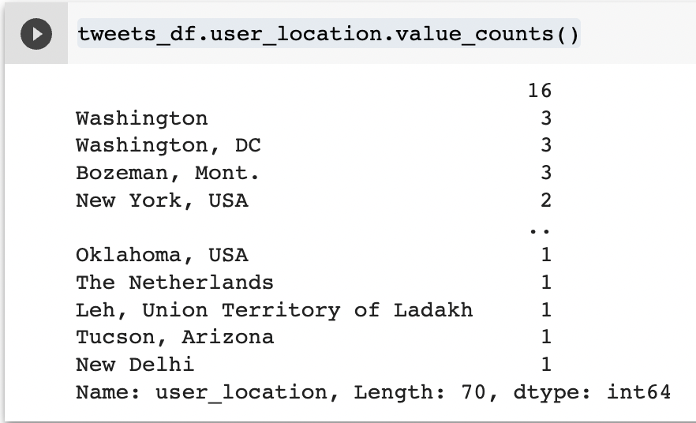

Check for value counts on the location attribute suggests that most numbers of the tweets in the data frame are from Washington, followed by New York and others.

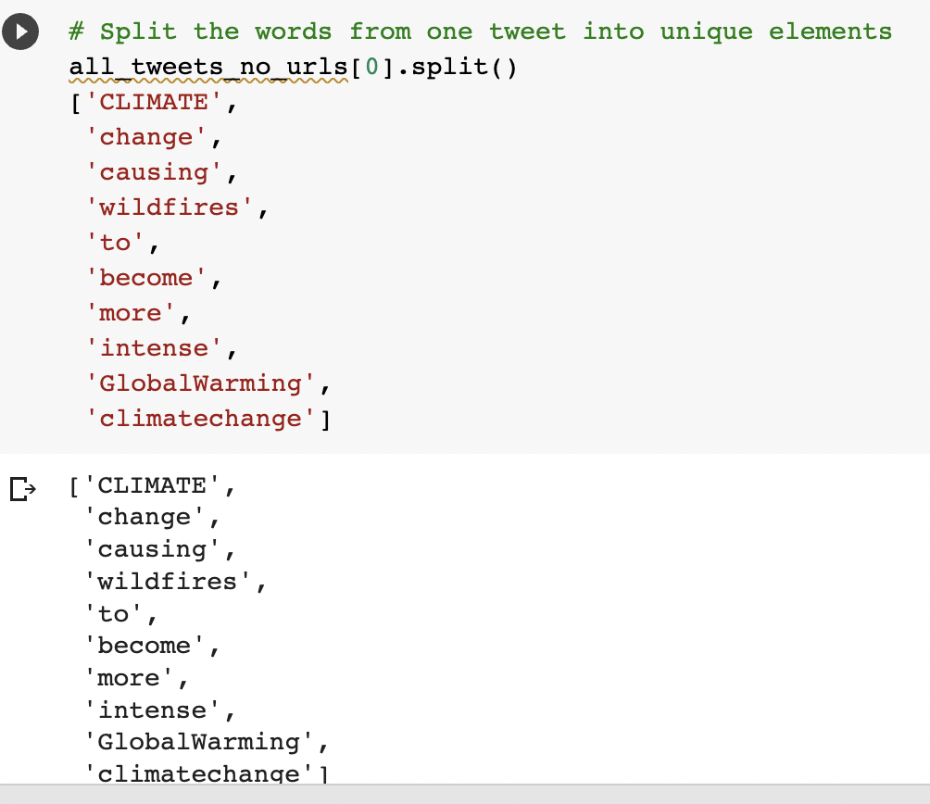

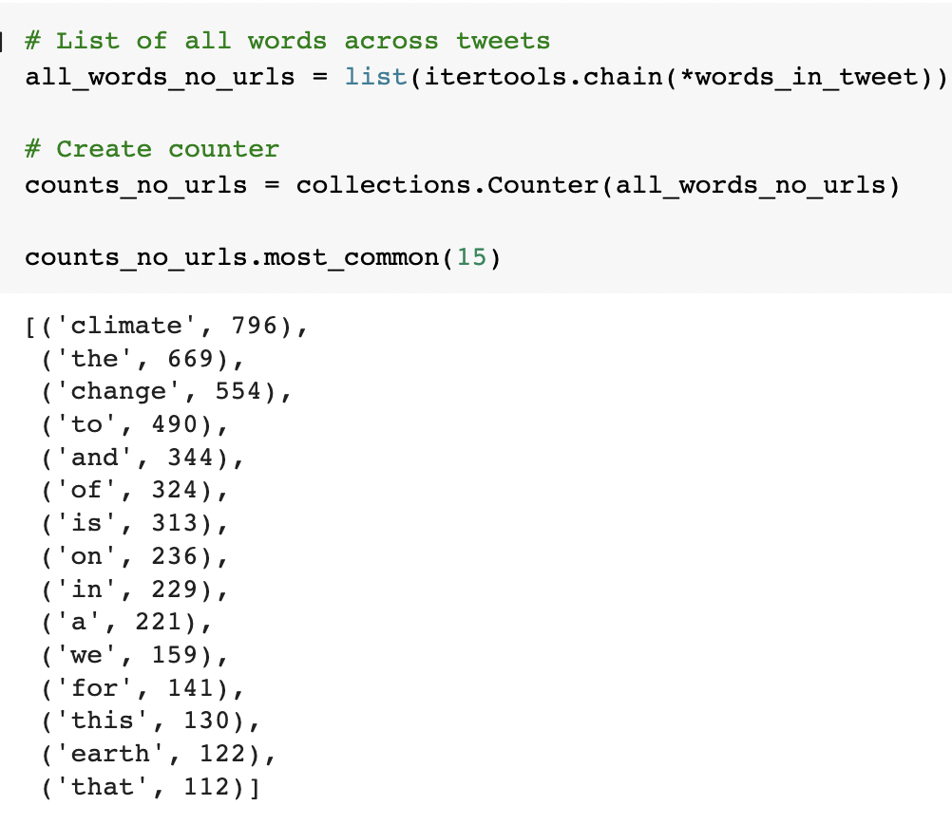

The following query gives the count of words in the tweets.

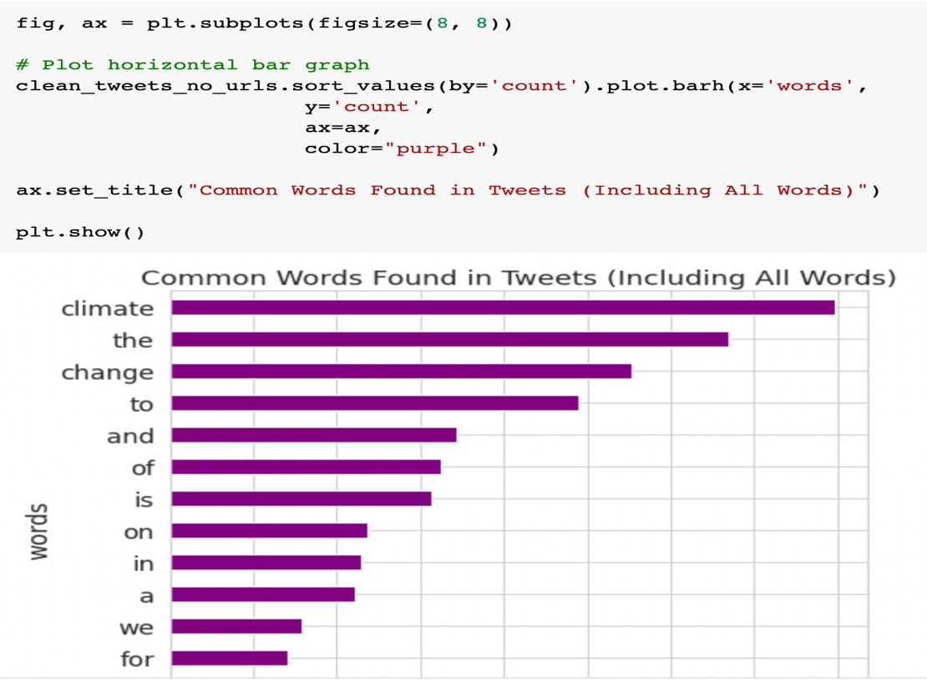

This bar graph is the illustration of common words which are found in tweets.

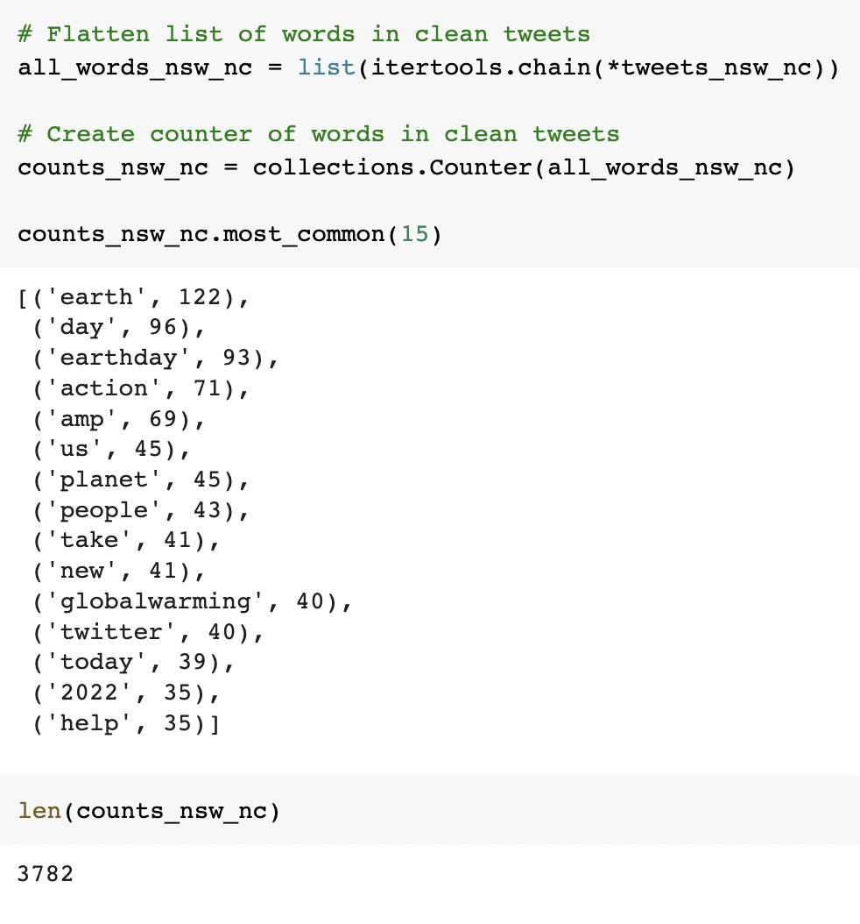

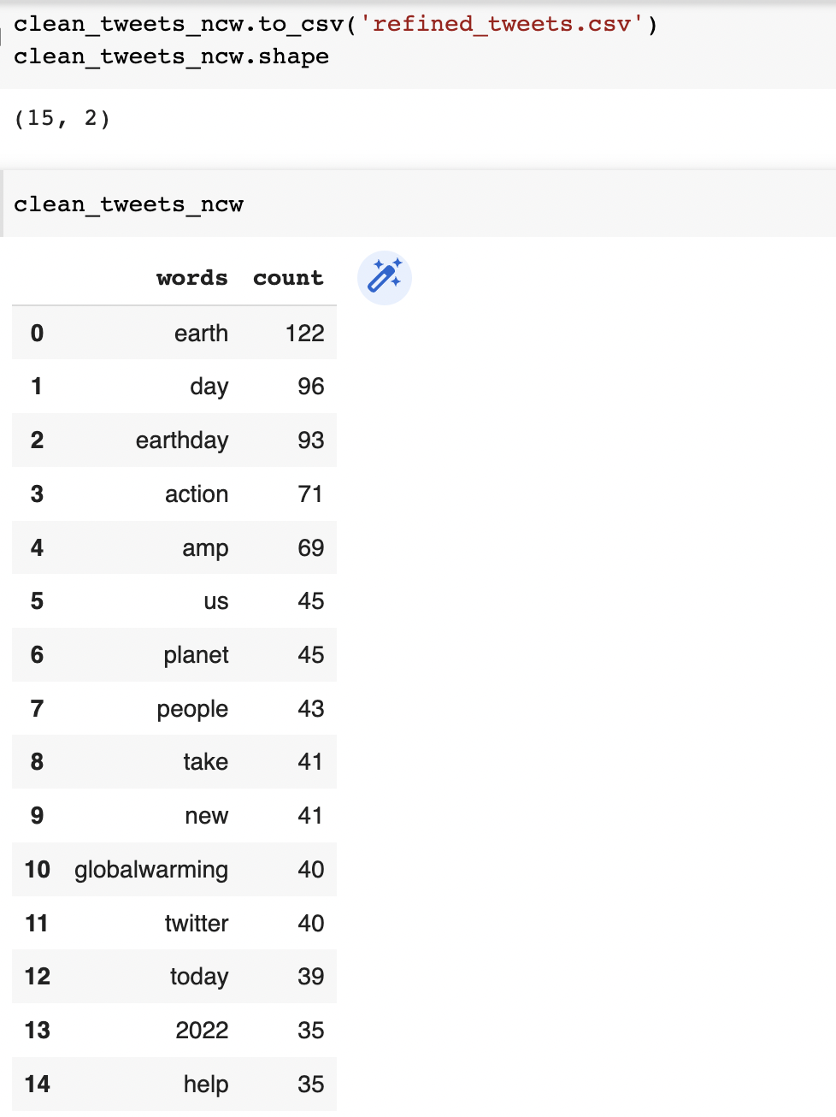

As seen above, the data frame dimension is 15 rows and 2 columns.

1. **Part 2: Sentimental Analysis**

Sentiment analysis is a method of identifying attitudes in text data about a subject of interest. It is scored using polarity values that range from 1 to -1. Values closer to 1 indicate more positivity, while values closer to -1 indicate more negativity.

We have used the Python package textblob to calculate the polarity values of individual tweets. For this analysis, we want to include emojis as they represent sentiment. This step has not been included below.

Begin by creating textblob objects, which assign polarity values to the tweets. We can identify the polarity value using the attribute polarity of the texblob object.

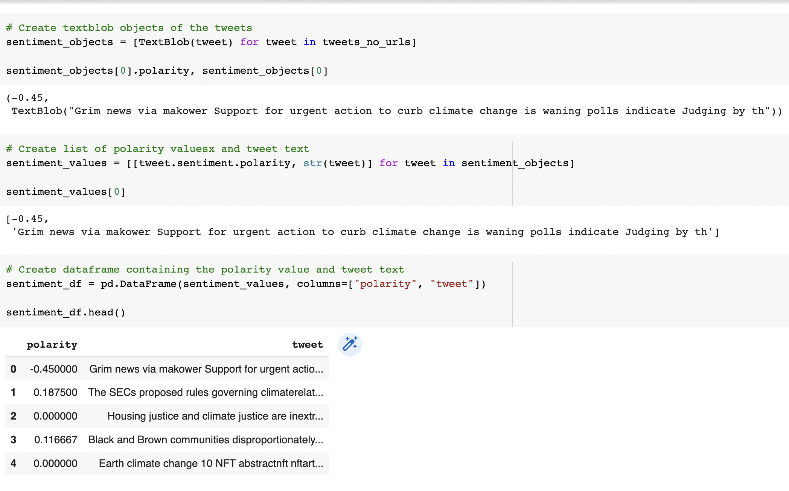

1. I created textblob objects of tweets and then made a list of polarity and tweet text
2. Created data frame containing the polarity value and tweet text

With these finally, I have shown an example of NASA’s moment by removing the sentiments of tweets having NASA in them.

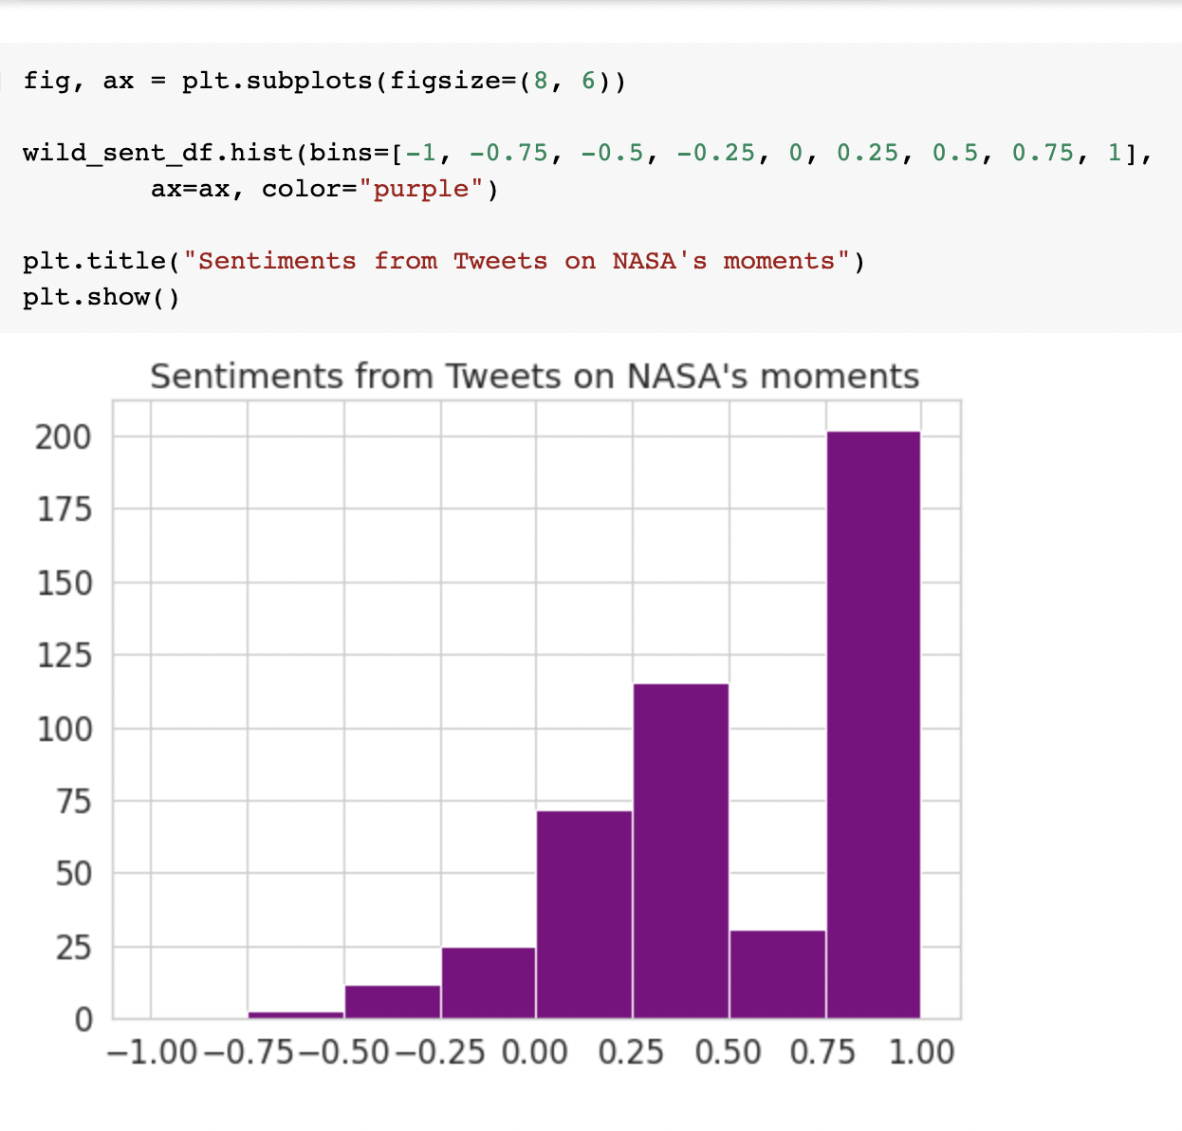

1. **Part 3: Using JSON File with Twitter Data in Python**

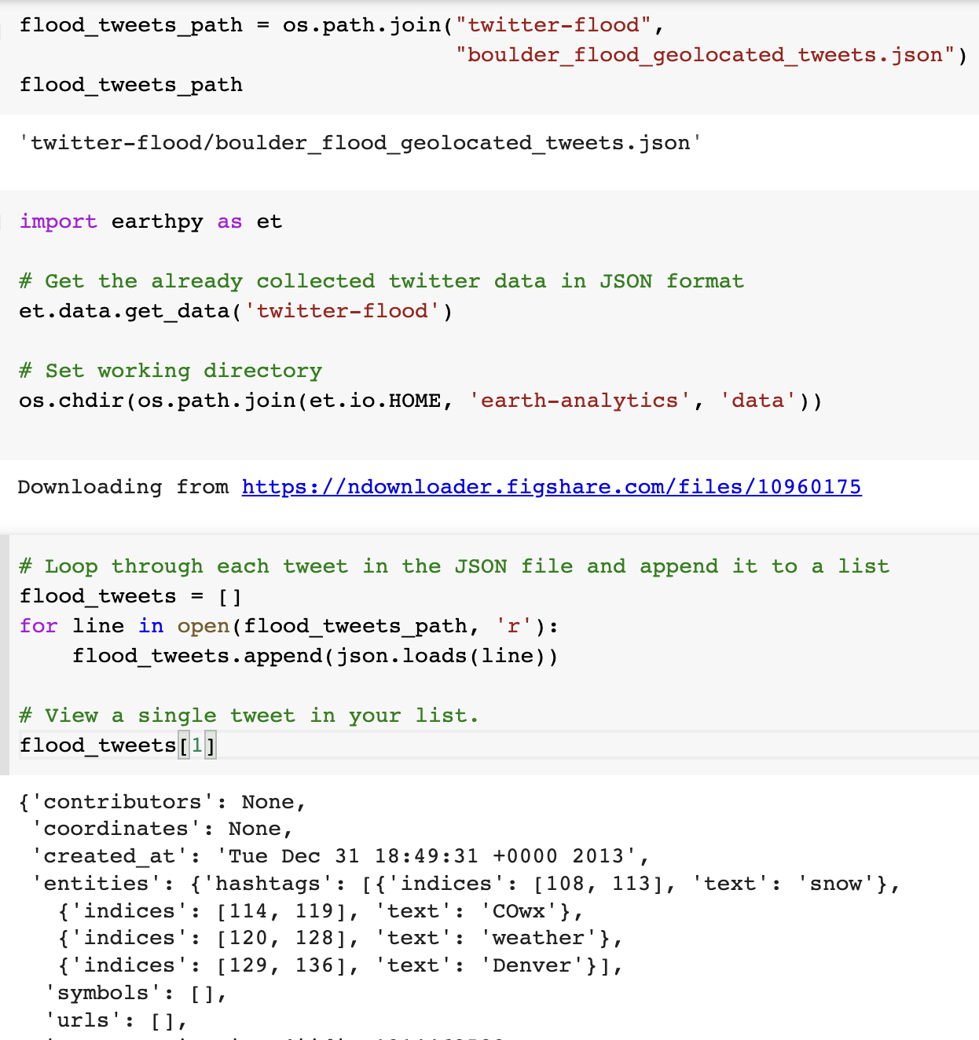

Here, we are giving a JSON input and setting a working directory, and then appending each tweet in a JSON file.

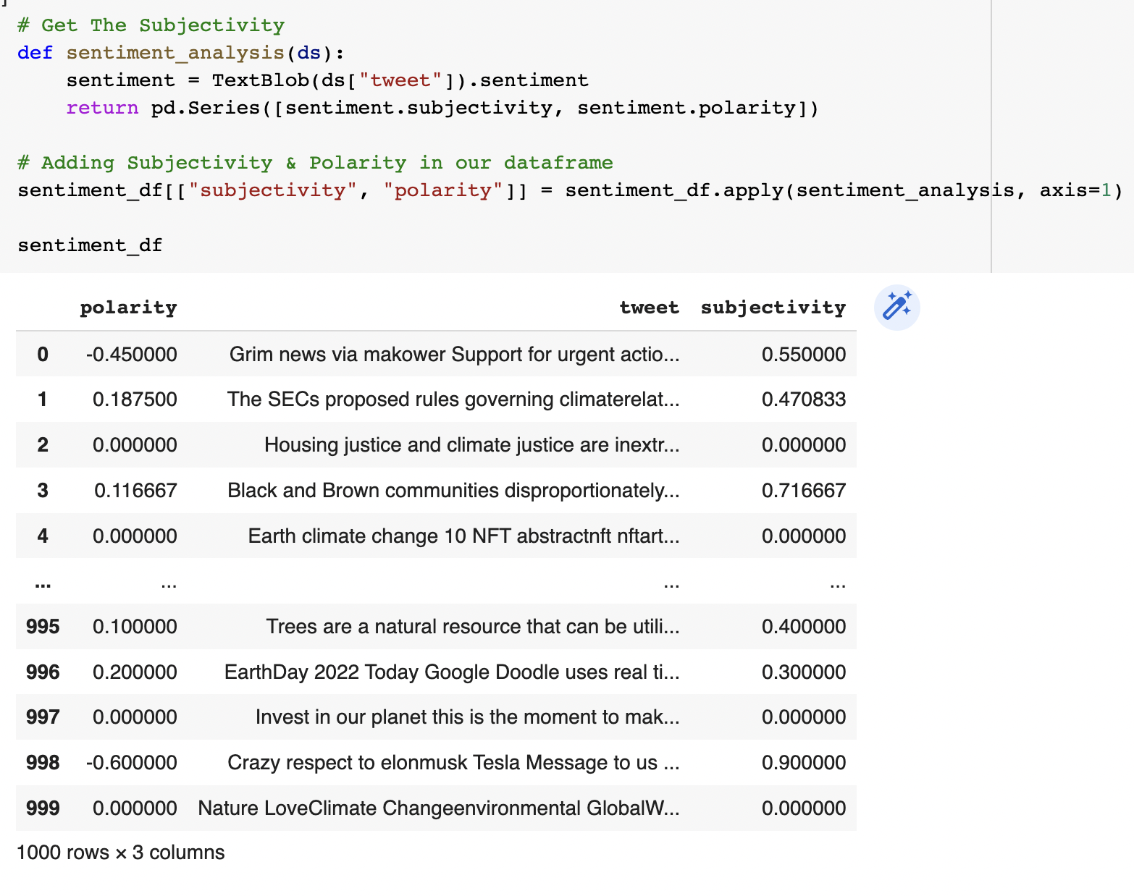

Then, I have done the sentimental analysis of a series of data and then added subjectivity and polarity to my data frame

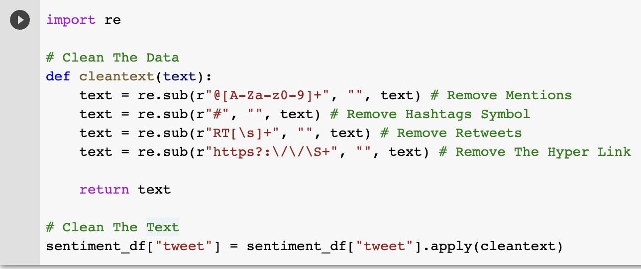

Here, I have cleaned the text by removing irrelevant information like hashtags, mentions, retweets, and links.

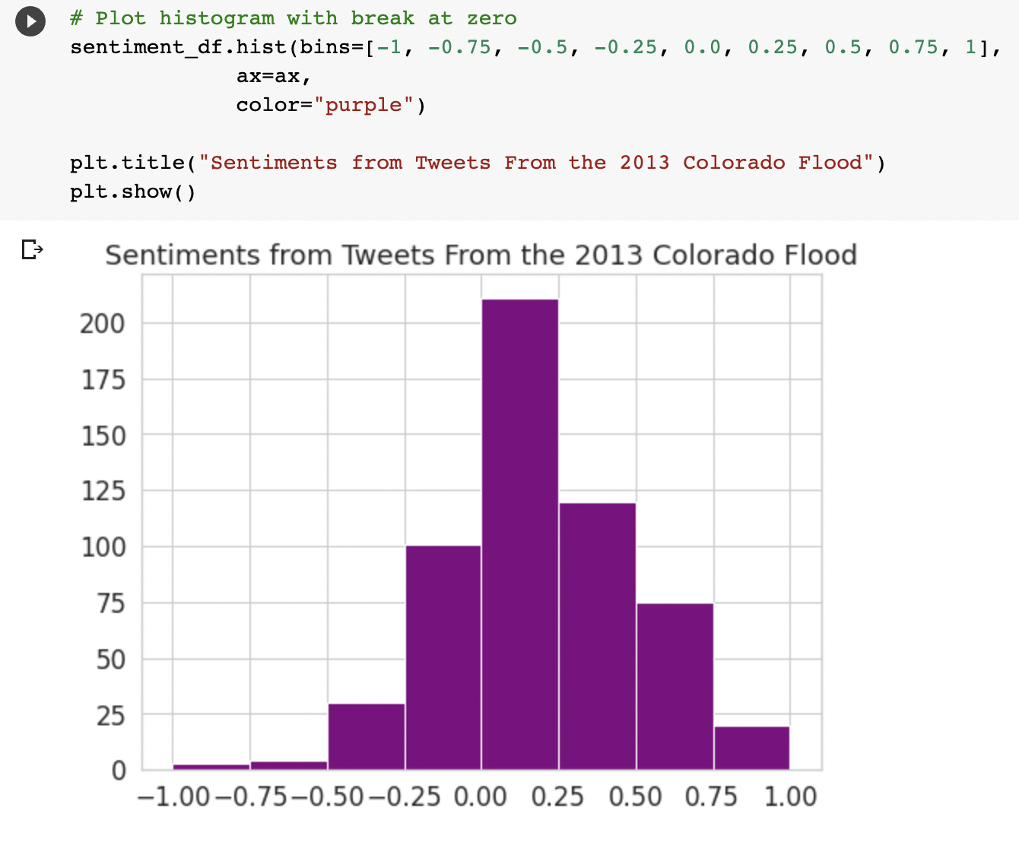

This plot displays a revised histogram of polarity values for tweets on climate change. For this histogram, polarity values equal to zero have been removed, and a break has been added at zero, to better highlight the distribution of polarity values

1. **Part 6: Extracting tweets by username for analysis**

Here, I have extracted 200 tweets by username @JoeBiden using user_timeline() method of tweepy, and then iterated through each tweet to add them to the list.

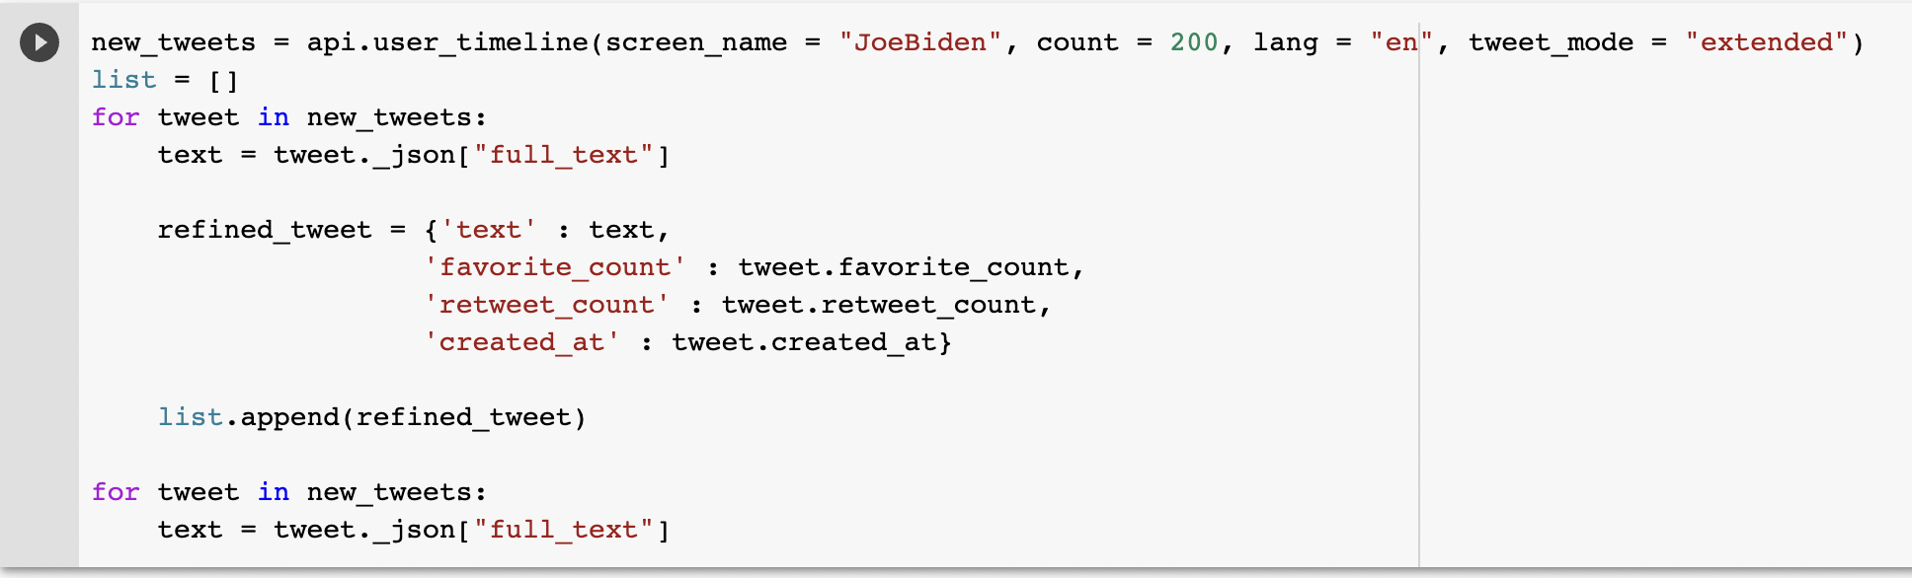

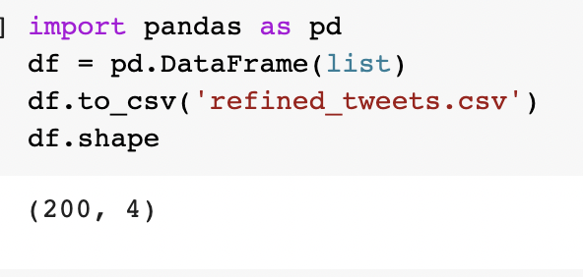

As seen above, the data frame dimension is 200 rows and 4 columns. Columns are namely text, favorite_count, retweet_count, and created_at.

Created_at column is a time stamp. We converted it to datetime type of pandas and extracted date from the same.

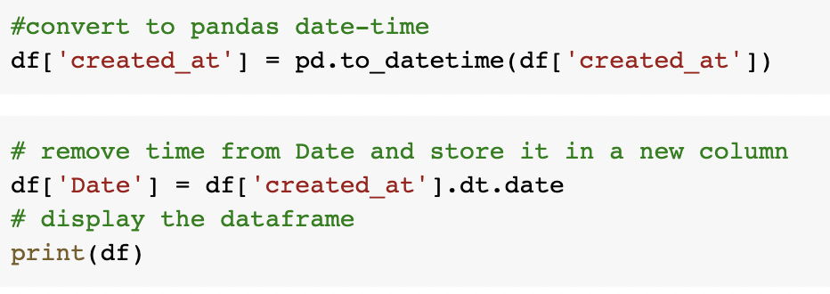

The number of tweets per month is calculated with the values counts command as shown below

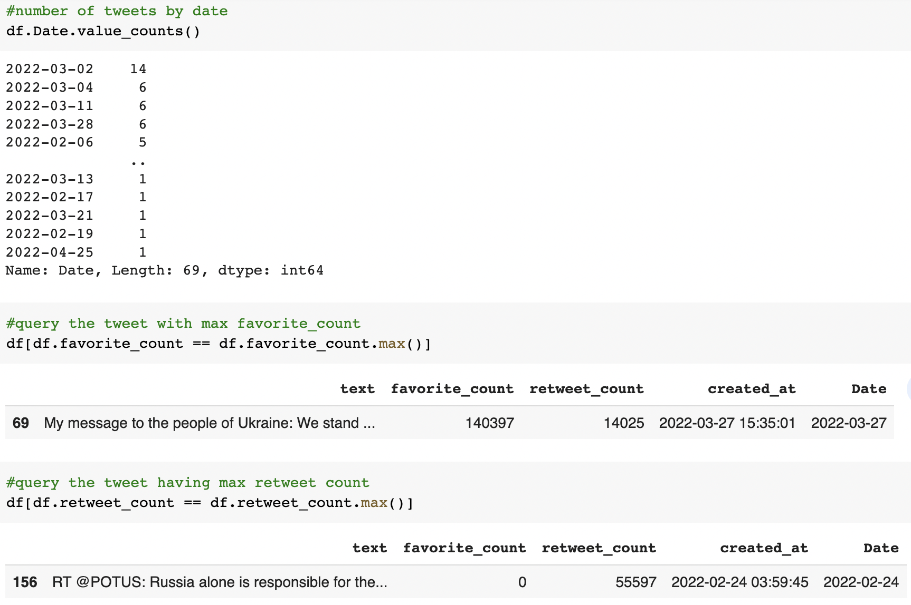

The final business questions are to query the tweet with the most favorite count and the tweet with the most retweet count. As shown above, we use the max () function to answer these business queries.

Next, I created a word cloud to find the most frequent and relevant words used in the text message.

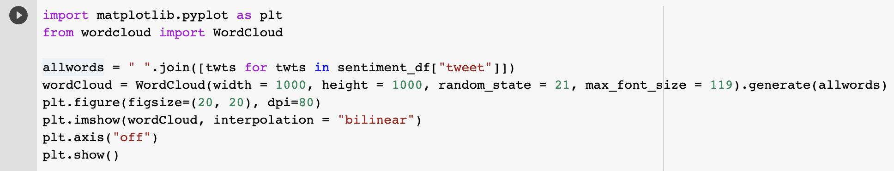

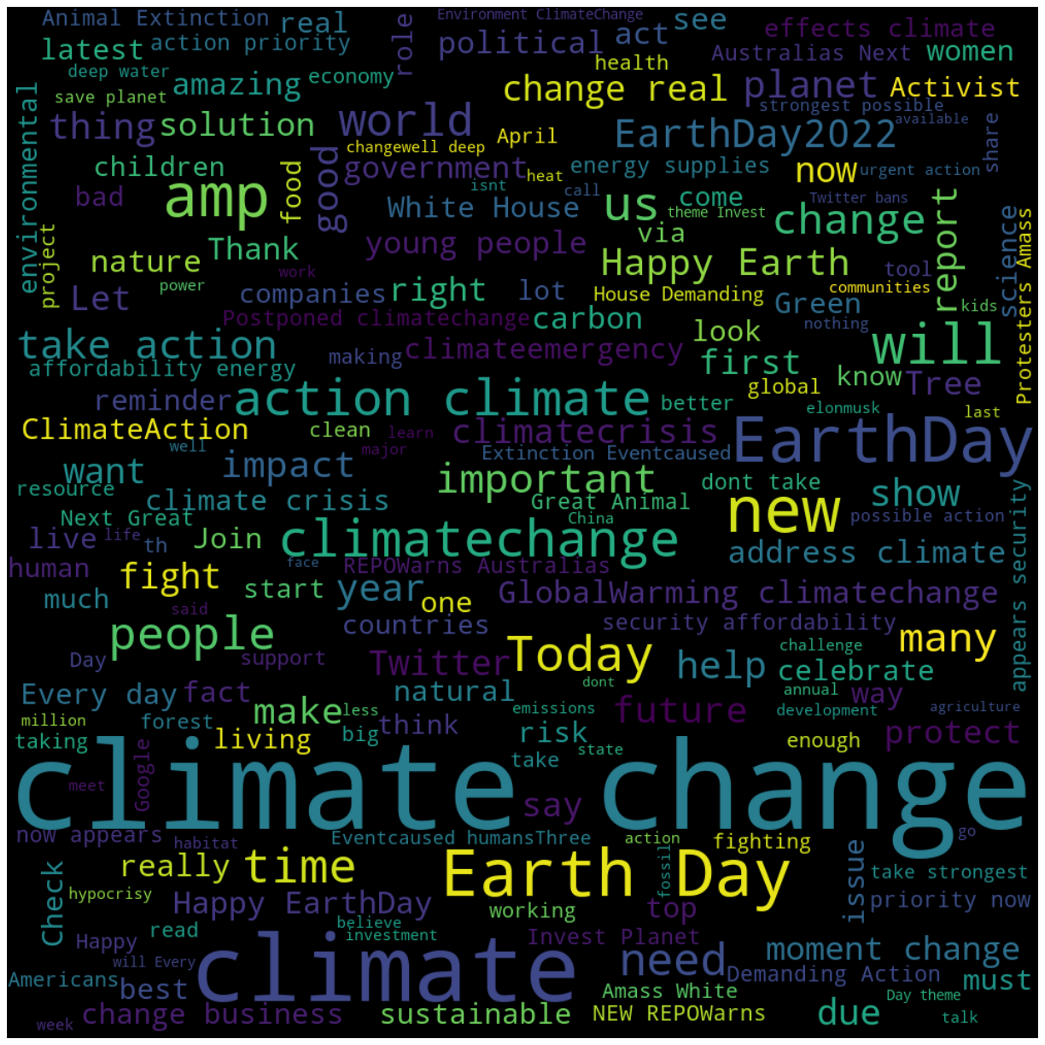

**Conclusion:**

These were my twitter analysis, where I covered user analysis, hashtag extraction and analysis, and then the sentimental analysis.